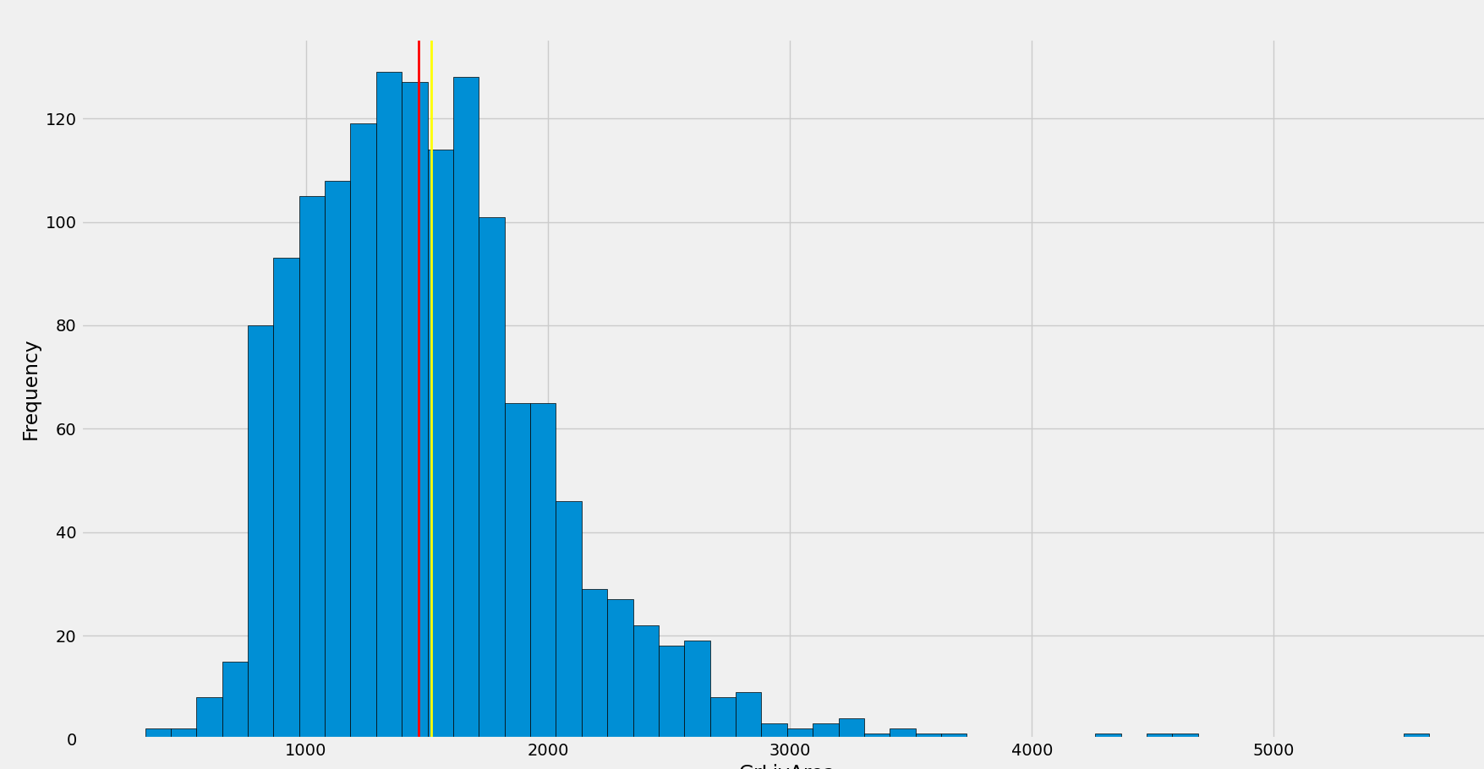

count 1460.000000

mean 1515.463699

std 525.480383

min 334.000000

25% 1129.500000

50% 1464.000000

75% 1776.750000

max 5642.000000

Skew: 1.3665603560164552

Kurtosis: 4.895120580693174

Is positively skewed and show peakedness3

Before Pre-Processing:

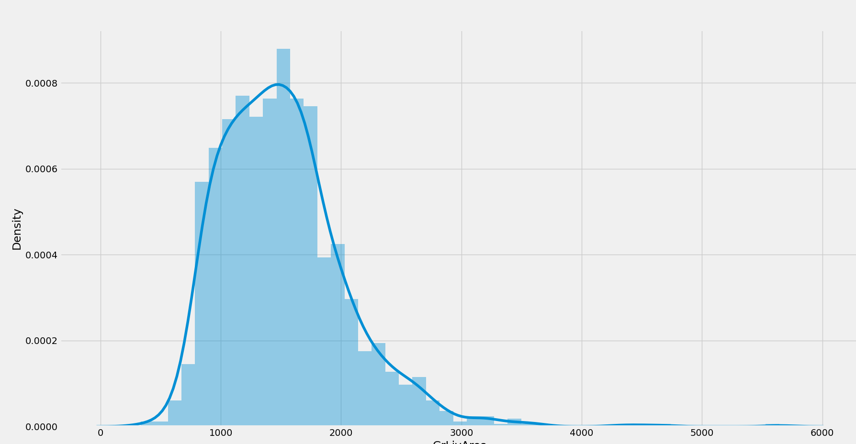

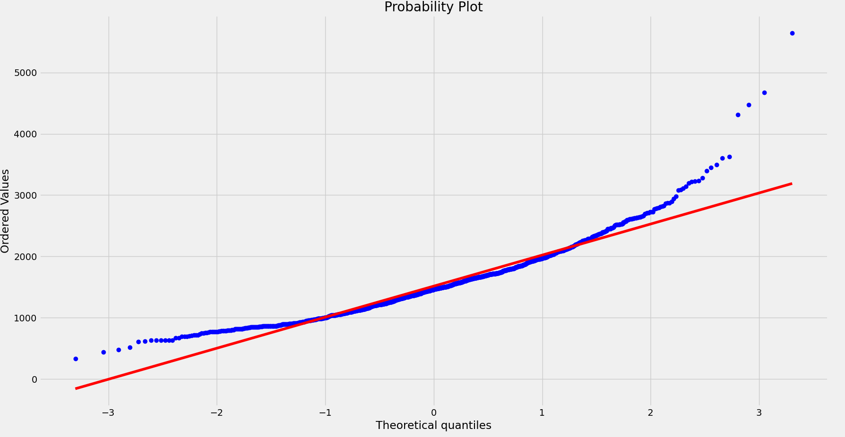

**After Log Transform:**

count 1460.000000

mean 7.267774

std 0.333550

min 5.811141

25% 7.029530

50% 7.288928

75% 7.482541

max 8.637994

Name: GrLivArea, dtype: float64

-0.006995182187690808

0.28260268850118564

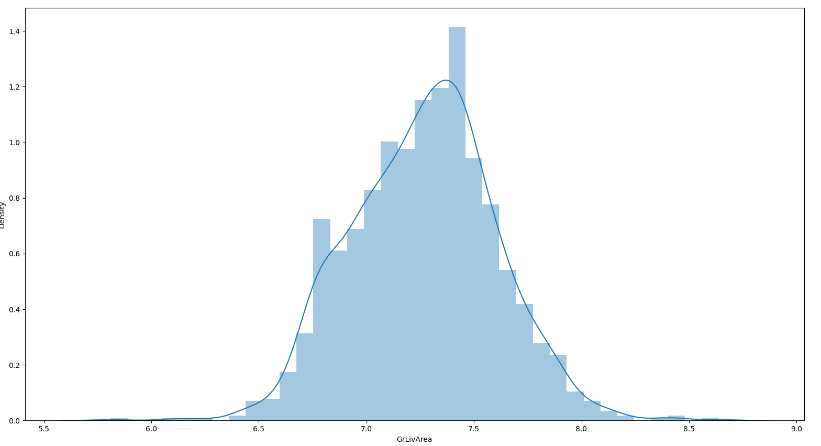

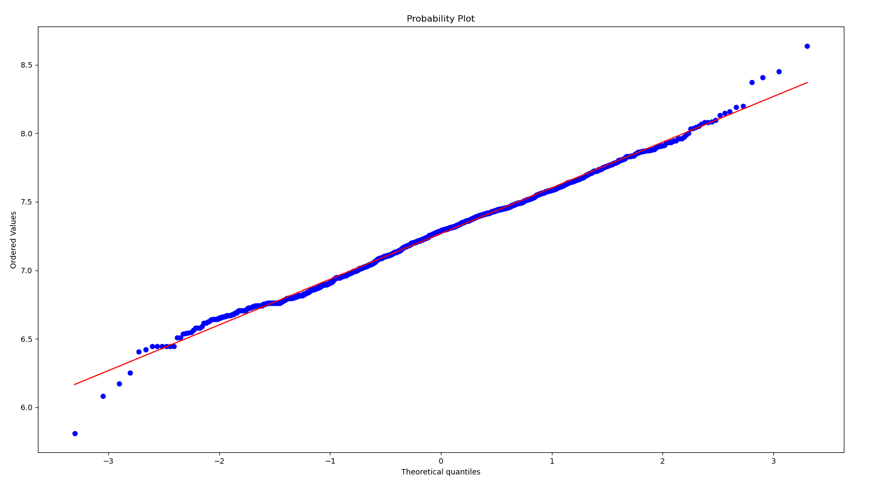

**After Scaling**

count 1.460000e+03

mean -1.277517e-16

std 1.000343e+00

min -2.249120e+00

25% -7.347485e-01

50% -9.797004e-02

75% 4.974036e-01

max 7.855574e+00

skew: 1.3665603560164552

kurtosis: 4.895120580693172

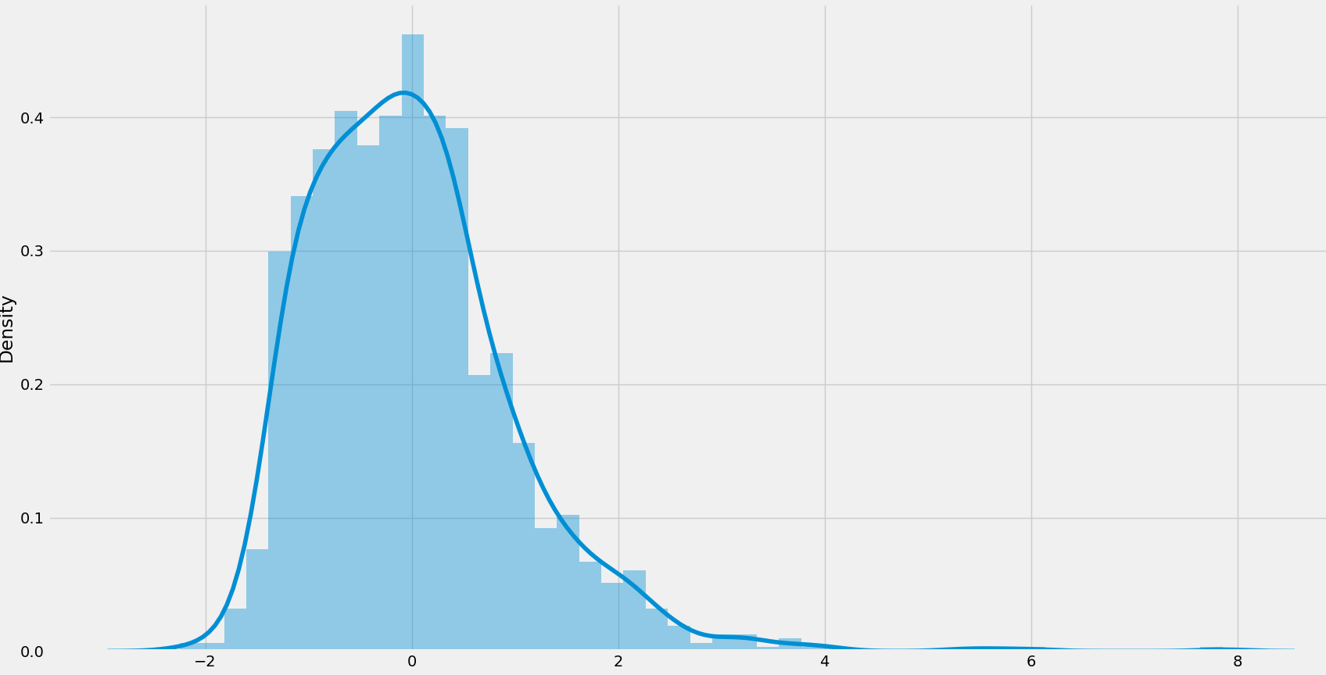

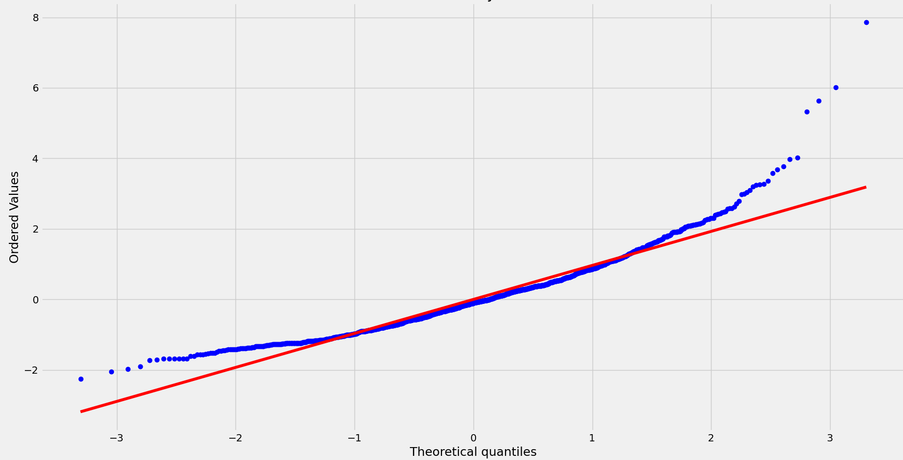

**GrLivArea vs SalePrice**

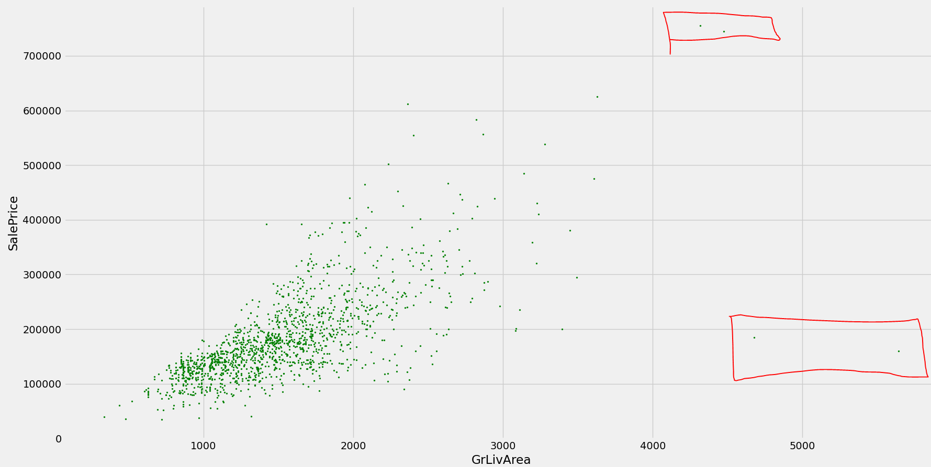

Linear relationship. 4 outliers. Remove top2 from the GrLiveArea

**Correlation:**

GrLivArea 0.708624